STARWELDING TORCHES WT28

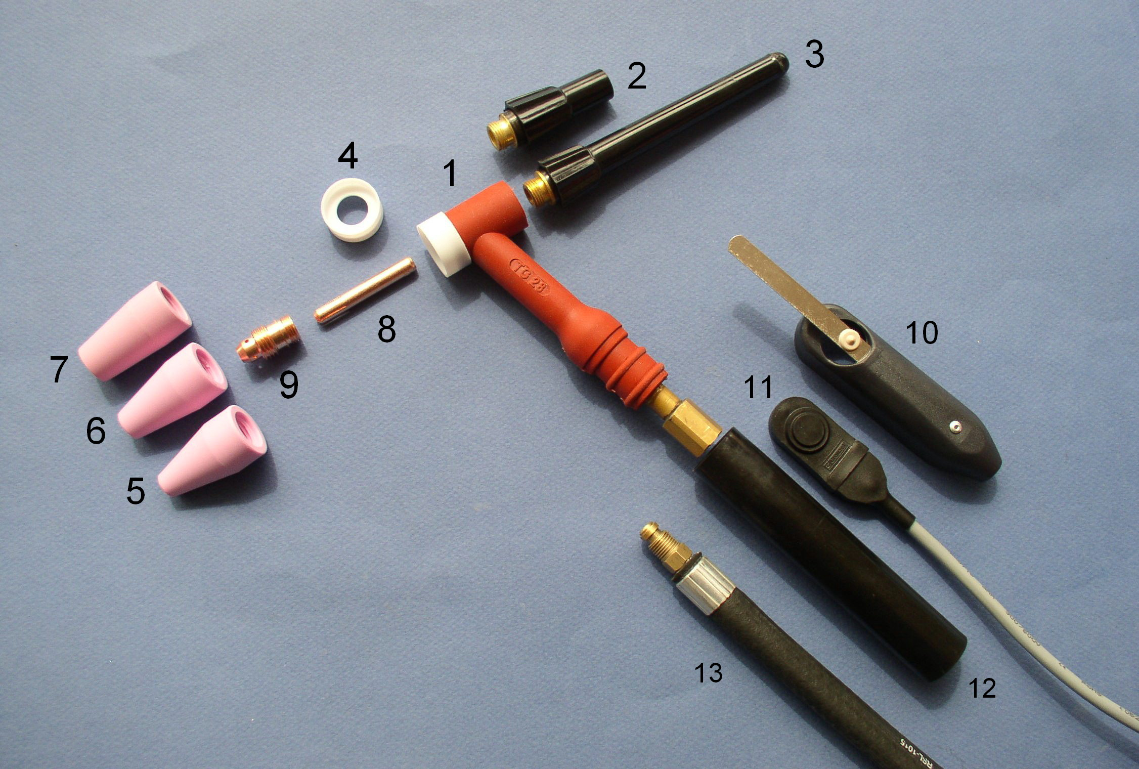

REPERE | REFERENCE | DESIGNATION
1 | WT28 | CORPS DE TORCHE
2 | 28Y04 | BOUCHON COURT
3 | 28Y02 | BOUCHON LONG
4 | 28CG | BAGUE D’ETANCHEITE
5 | 28N07 | BUSE CERAMIQUE D7.0MM
6 | 28N09 | BUSE CERAMIQUE D9.0MM
7 | 28N12 | BUSE CERAMIQUE D12.0MM
8 | 28N16 | PINCE D1.6 MM
8 | 28N20 | PINCE D2.0 MM
8 | 28N24 | PINCE D2.4 MM
8 | 28N32 | PINCE D3.2 MM
9 | 28CB20 | PORTE PINCE TOUS DIAMETRES D1.6 – 3.2 MM
10 | SL1 | GACHETTE A LAMELLE
11 | SW1F | MICRORUPTEUR COMPLET (sans câble)
12 | H100G | MANCHE
13 | 28V04 | CABLE DE PUISSANCE LONG. 4M
13 | 28V06 | CABLE DE PUISSANCE LONG. 6M
13 | 28V08 | CABLE DE PUISSANCE LONG. 8M

